Steps to use Honorlock for MPT:
What you’ll need before getting started: Webcam, Google Chrome, a photo ID, plain white scrap paper, scientific (non-graphing) calculator.
1) Open Google Chrome. If you don’t have Chrome, please download it. This will not work in any other browser.
2) Log into Canvas and select the MAT 00X: Math Placement Test course. To log into Canvas go to:
www.strose.edu/login and select Login to Canvas. The username and password are the same that you used for your Saint Rose email login (if you have not set up your Saint Rose email, please do so first).
3) On the left-hand side, click the link that says Honorlock.
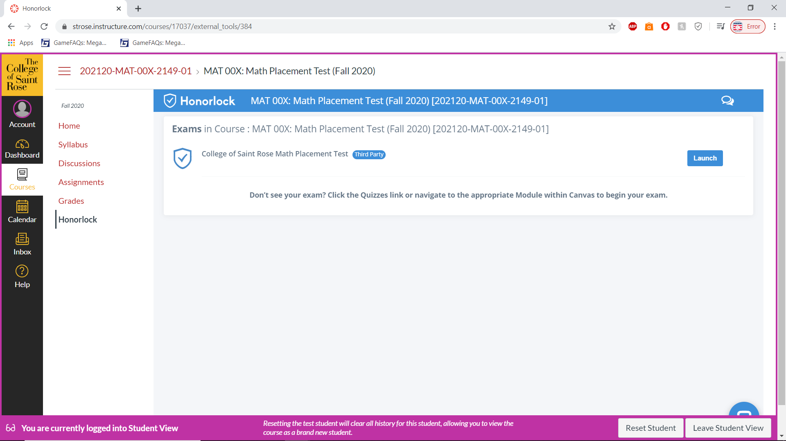
4) The browser will prompt you to download the Honorlock extension. Please do so.

5) Once completed, you will now be able to navigate to the math placement webpage by selecting the assignment from this page:

6) Follow the protocols for the proctoring identification. You will need to have your computer take your picture, show your ID (can be government issued or school issued), perform a 360-room scan and scan of your work area. (Screenshots follow on the next page)

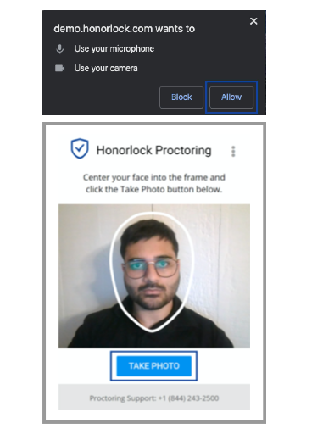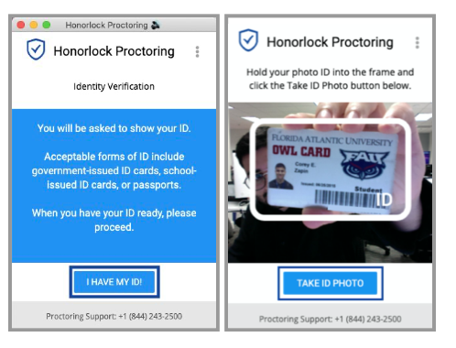
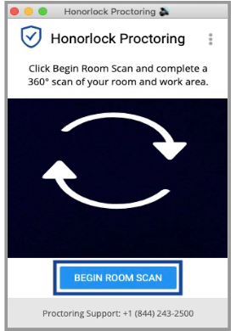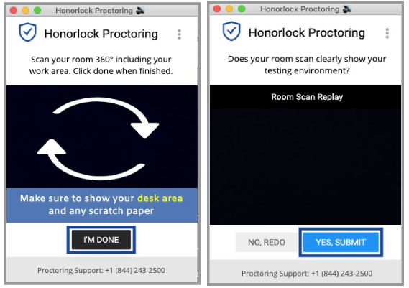

7) Launch Screen Recording
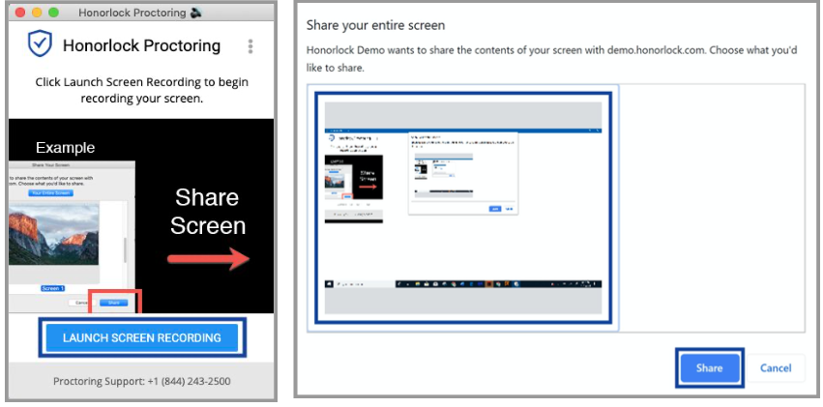
https://honorlock.kb.help/-students-starting-exam/how-to-use-honorlock-with-a-universal-exam-student/

8) Once at the MPT site, you will login using the following credentials: UN- ID number, PW: Mathisfun!

9) Select the Math Placement Test course, then select the option at the bottom of the page that says CSR MPT 2 (STAR Day). Do Not select any other version that you see. This will only work with the STAR Day version!

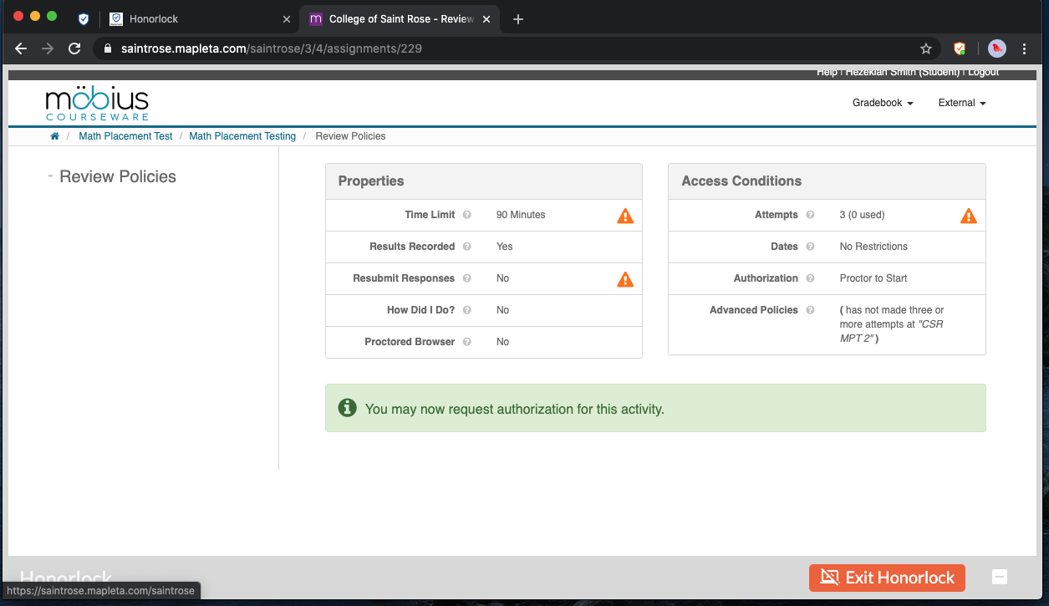
10) On the bottom of your screen should be a small white button that will allow you to minimize the Honorlock bar. You need to click that before you click the Request Authorization button.

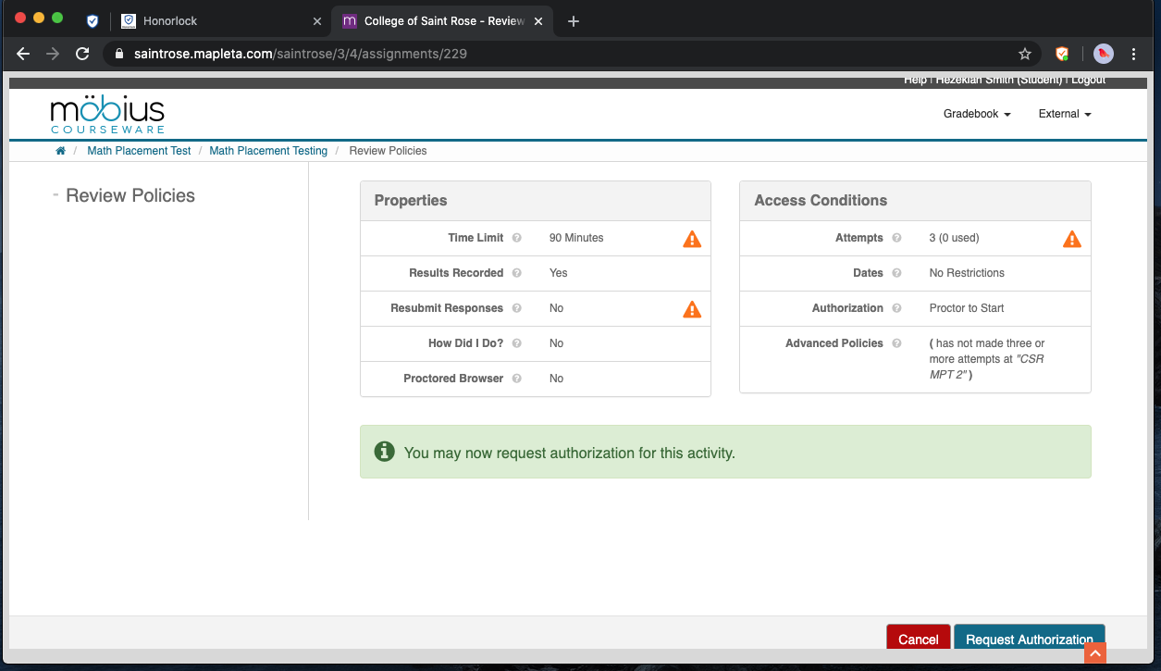

11) After clicking Request Authorization, there will be several boxes that appear on the screen. Select the top box that says Assignment Password and click once in this box. On the Honorlock window (the one with the picture of you, click the button that says Input Password. This will autofill the password and you can then click Submit Password.
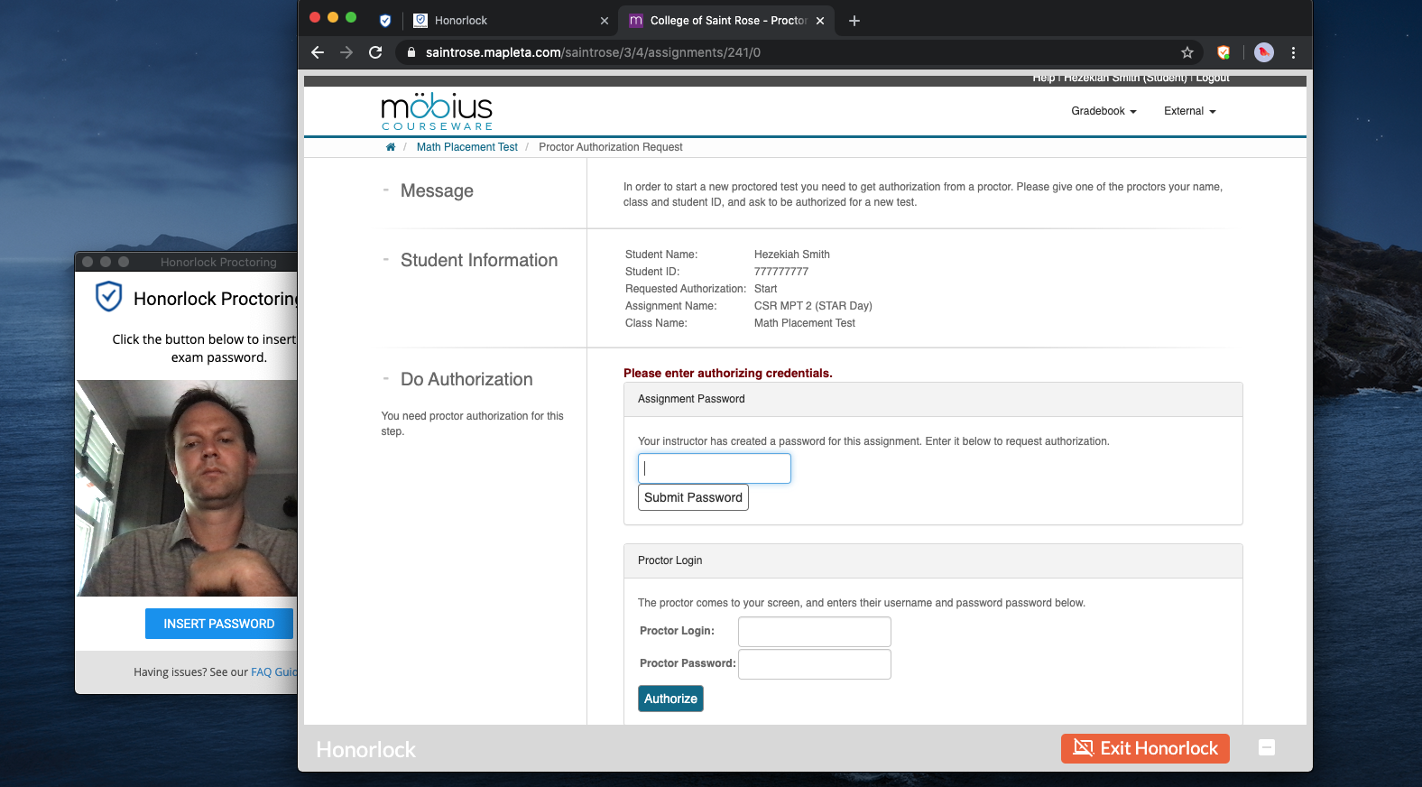
This is the box that you want
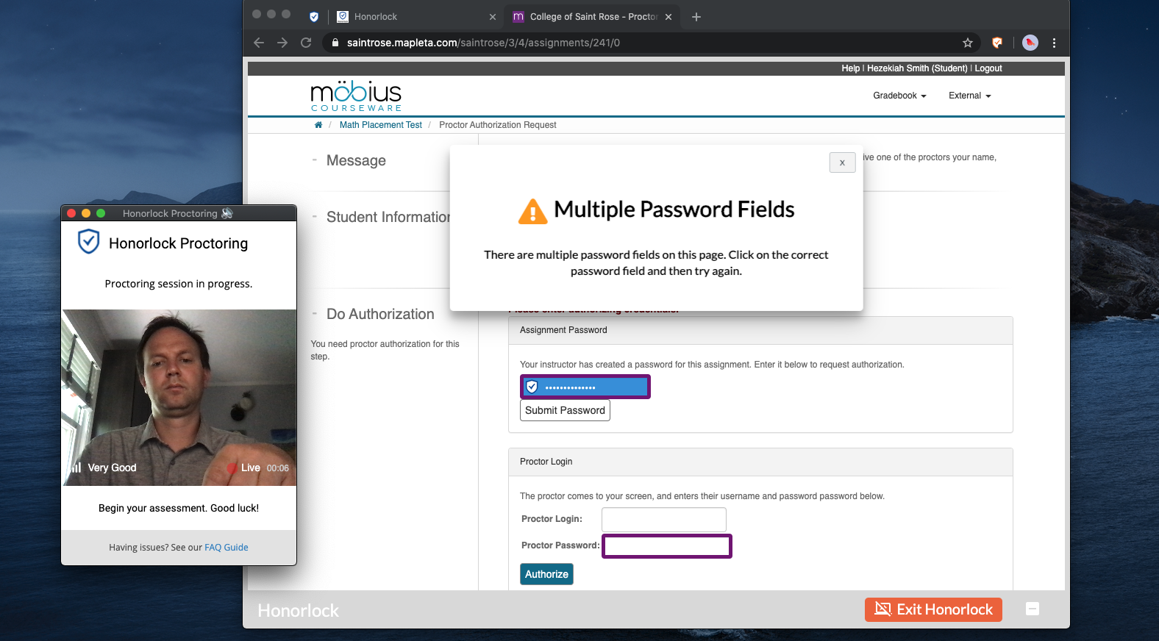

12) You will now be able to take the Math Placement Test. Select your choice for each question, then click the minimize button as before and click Next. Repeat this step for all 30 questions. There is no way to skip a question and return to it, so answer each question before you proceed. Once you have made your choice for question 30, the Next button will fade away. Click Submit Assignment. Only click this button if you are on question 30.
13) Consult the grid at the end of the Placement to determine if you were able to achieve the score you need for your major. If you need to retake the placement, contact Matt Woods at woodsm@strose.edu, or at 518-454-2177 to set up time to either review the test or to schedule a retest.
14) Your score will be uploaded to your Degreeworks page within one business day of completing the test.

If you have any questions or difficulties using Honorlock, please feel free to reach out to Matt Woods at 518-454-2177 or at woodsm@strose.edu.

